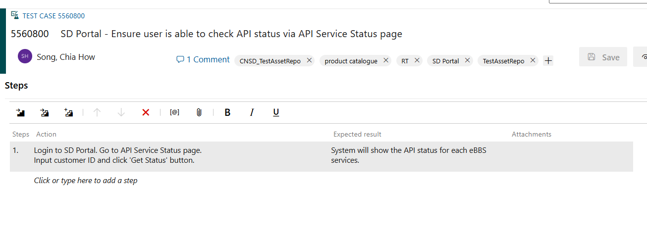
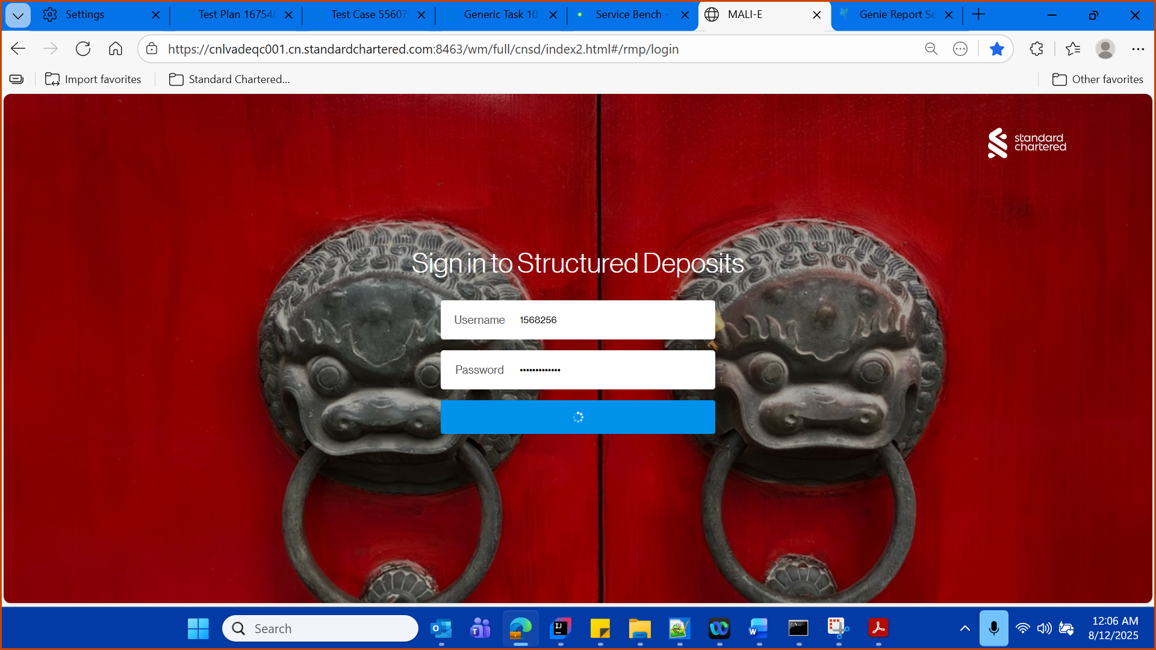

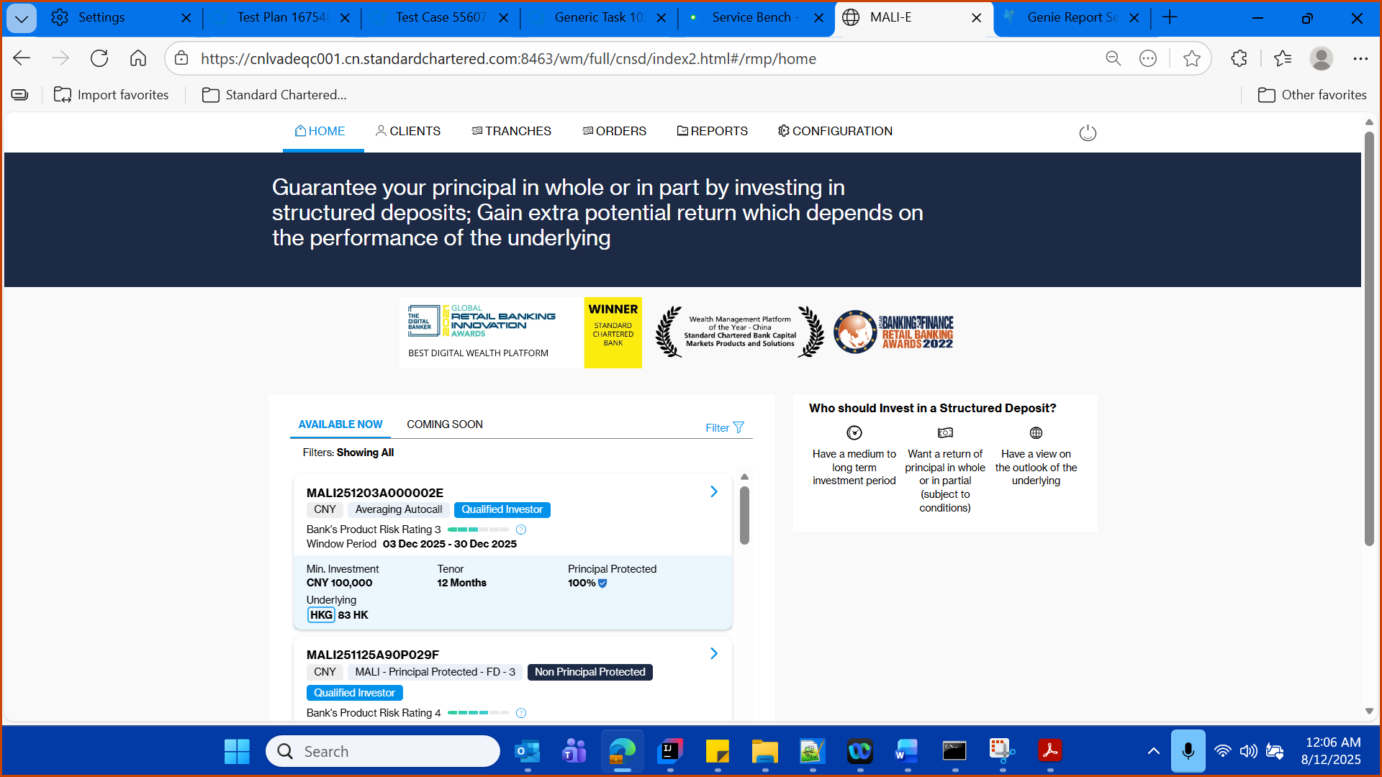

- Check the API Service Status with maker login

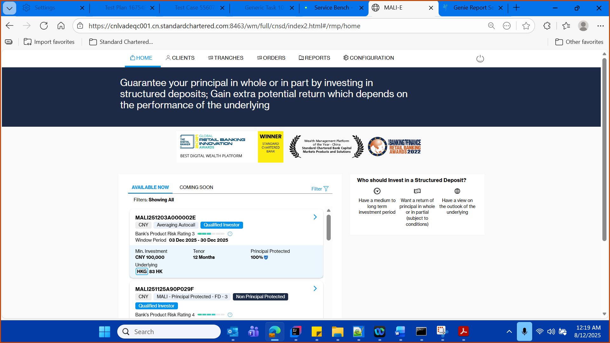

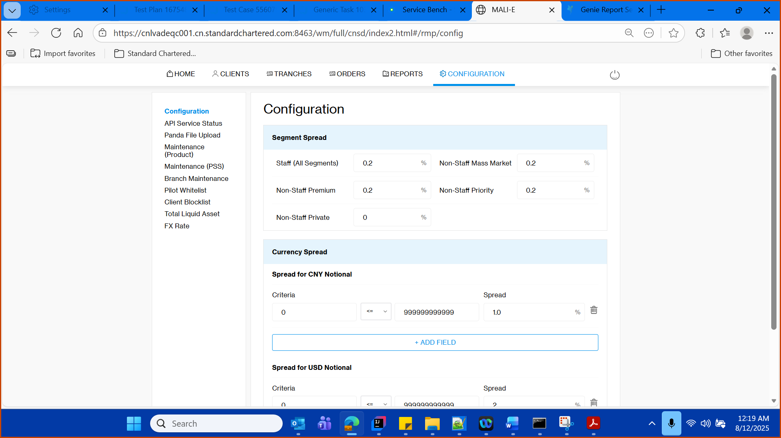

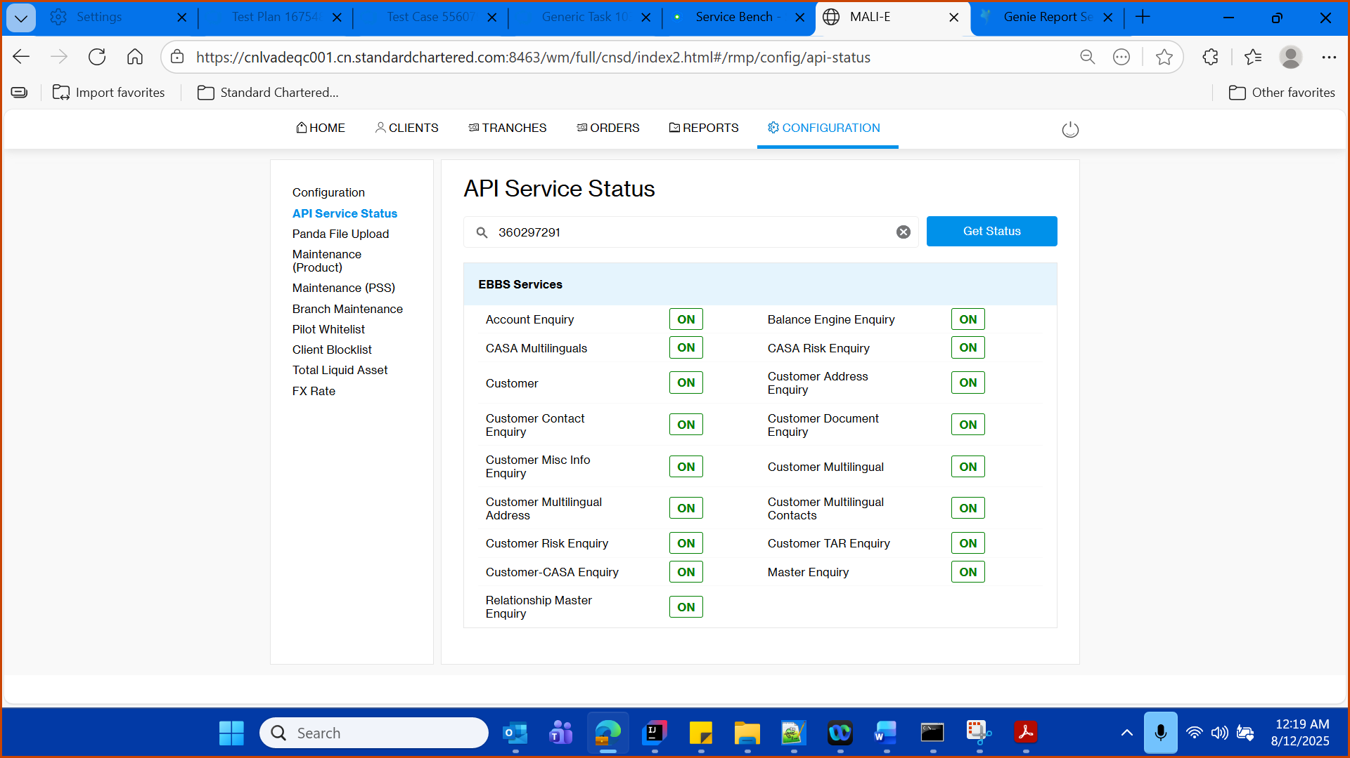

Validate the title

Enter client id in the given field

360297291

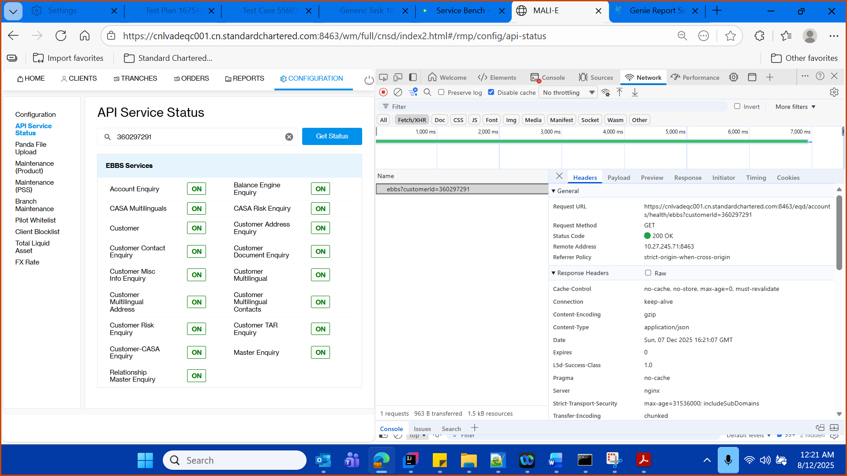

End point
https://cnlvadeqc001.cn.standardchartered.com:8463/eqd/accounts/health/ebbs?customerId=360297291

Validate the content of the UI with API response

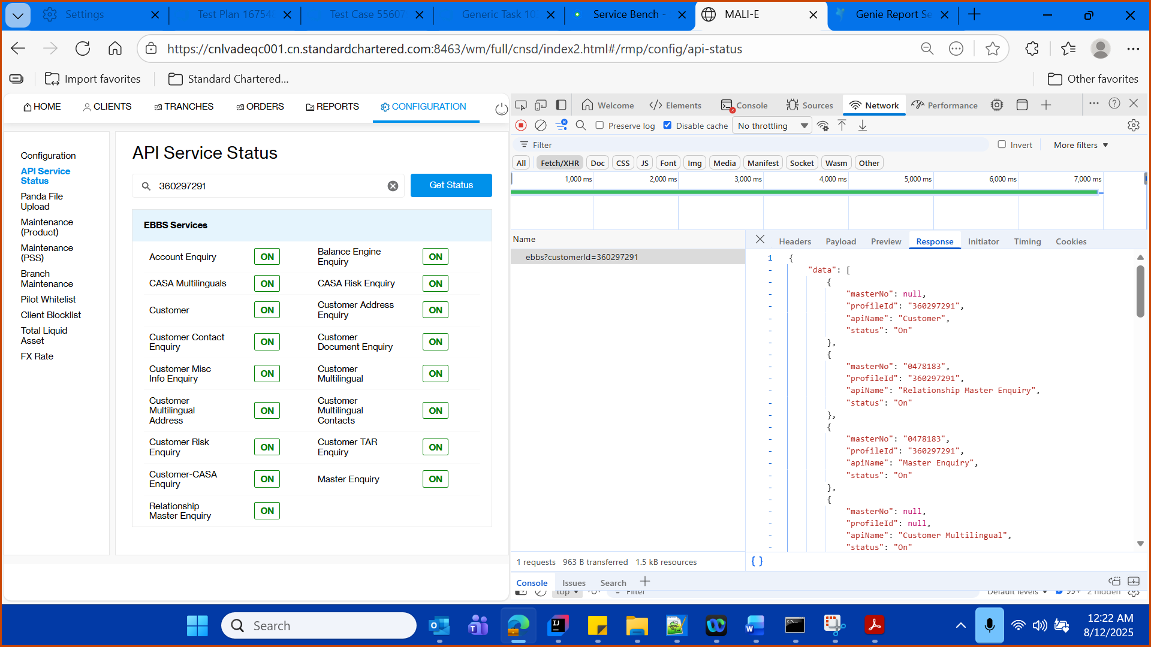

API response
{
"data": [
{
"masterNo": null,
"profileId": "360297291",
"apiName": "Customer",
"status": "On"
},
{
"masterNo": "0478183",
"profileId": "360297291",
"apiName": "Relationship Master Enquiry",
"status": "On"
},
{
"masterNo": "0478183",
"profileId": "360297291",
"apiName": "Master Enquiry",
"status": "On"
},
{
"masterNo": null,
"profileId": null,
"apiName": "Customer Multilingual",
"status": "On"
},
{
"masterNo": null,
"profileId": "360297291",
"apiName": "Customer Contact Enquiry",
"status": "On"
},
{
"masterNo": null,
"profileId": "360297291",
"apiName": "Customer Address Enquiry",
"status": "On"
},
{
"masterNo": null,
"profileId": "360297291",
"apiName": "Customer Risk Enquiry",
"status": "On"
},
{
"masterNo": null,
"profileId": "360297291",
"apiName": "Customer-CASA Enquiry",
"status": "On"
},
{
"masterNo": null,
"profileId": null,
"apiName": "CASA Risk Enquiry",
"status": "On"
},
{
"masterNo": null,
"profileId": "360297291",
"apiName": "Customer Misc Info Enquiry",
"status": "On"
},
{
"masterNo": null,
"profileId": "360297291",
"apiName": "Customer TAR Enquiry",
"status": "On"
},
{
"masterNo": null,
"profileId": "360297291",
"apiName": "Customer Document Enquiry",
"status": "On"
},
{
"masterNo": "0478183",
"profileId": "360297291",
"apiName": "Account Enquiry",
"status": "On"
},
{
"masterNo": null,
"profileId": null,
"apiName": "Customer Multilingual Contacts",
"status": "On"
},
{
"masterNo": null,
"profileId": "360297291",
"apiName": "Customer Multilingual Address",
"status": "On"
},
{
"masterNo": null,
"profileId": "360297291",
"apiName": "CASA Multilinguals",
"status": "On"
},
{
"masterNo": null,
"profileId": "360297291",
"apiName": "Balance Engine Enquiry",
"status": "On"
}
]
}

-Verify the status code success.
